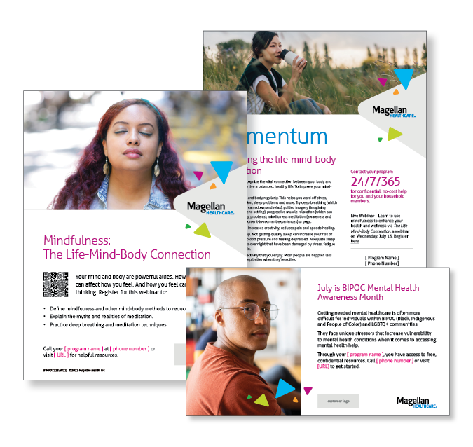
Monthly Theme – Employees
Improving the life-mind-body connection
It’s important to recognize the vital connection between your body and mind if you want to live a balanced, healthy life. Learn how to improve your mind-body health in this month’s newsletter.

Monthly Webinar – Employees
The Life-Mind-Body Connection | July 13
Join this webinar to:
- Define mindfulness and other mind-body methods to reduce stress.
- Explain the myths and realities of meditation.
- Practice deep breathing and meditation techniques.
Register here

How can you use these in your workplace?
- Email it to your workforce
- Post it on your Organization’s Benefits Intranet
- Print and post in lunch or break rooms

More Information Available Online!
Looking for more information? There is a whole library of content waiting for you at www.Magellanascend.com

